**KWASHIORKOR**

Kwashiorkor, also known as “edematous malnutrition” because of its association with edema (fluid retention), is a nutritional disorder most often seen in regions experiencing famine. It is a form of malnutrition caused by a lack of protein in the diet. People who have kwashiorkor typically have an extremely emaciated appearance in all body parts except their ankles, feet, and belly, which swell with fluid.

Most people who are affected by kwashiorkor recover fully if they are treated early. Treatment involves introducing extra calories and protein into the diet. Children who develop kwashiorkor may not grow or develop properly and may remain stunted for the rest of their lives. There can be serious complications when treatment is delayed, including coma, shock, and permanent mental and physical disabilities. Kwashiorkor can be life-threatening if it’s left untreated. It can cause major organ failure and eventually death.

**What causes kwashiorkor?**

Kwashiorkor is caused by a lack of protein in the diet. Every cell in your body contains protein. You need protein in your diet for your body to repair cells and make new cells. A healthy human body regenerates cells in this way constantly. Protein is also especially important for growth during childhood and pregnancy. If the body lacks protein, growth and normal body functions will begin to shut down, and kwashiorkor may develop.

Kwashiorkor is most common in countries where there is a limited supply or lack of food.. A limited supply or lack of food is common in developing countries during times of famine caused by natural disasters — such as droughts or floods — or political unrest. A lack of nutritional knowledge and regional dependence on low-protein diets, such the maize-based diets of many South American countries, can also cause people to develop this condition.

This condition is rare in countries where most people have access to enough food and are able to eat adequate amounts of protein. If kwashiorkor does occur in the United States, it can be a sign of abuse, neglect, or fad diets, and it’s found mostly in children or older adults. It can also be a sign of an underlying condition, such as HIV.

What are the symptoms of kwashiorkor?

The symptoms of kwashiorkor include:

* change in skin and hair color (to a rust color) and texture
* fatigue
* diarrhea
* loss of muscle mass
* failure to grow or gain weight
* edema (swelling) of the ankles, feet, and belly
* damaged immune system, which can lead to more frequent and severe infections
* irritability
* flaky rash
* shock
* How is kwashiorkor diagnosed?
* If kwashiorkor is suspected, your doctor will first examine you to check for an enlarged liver (hepatomegaly) and swelling. Next, blood and urine tests may be ordered to measure the level of protein and sugar in your blood.

Related images

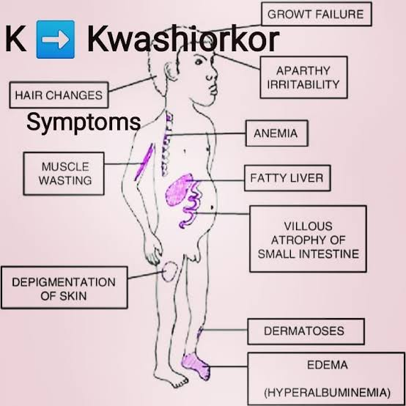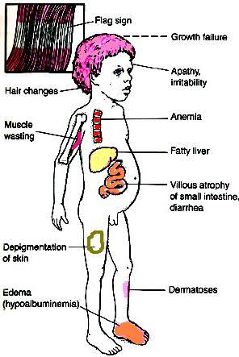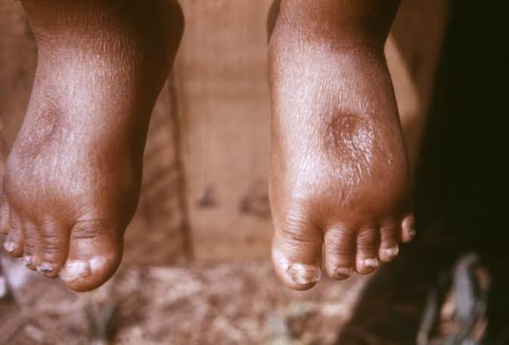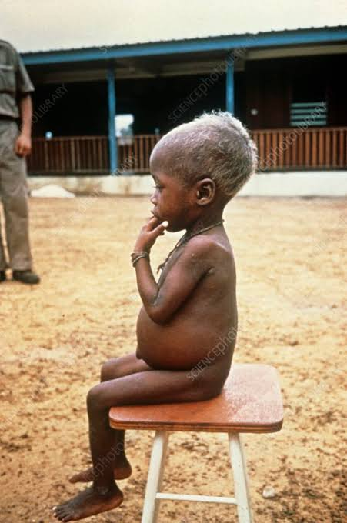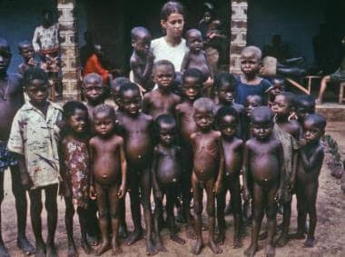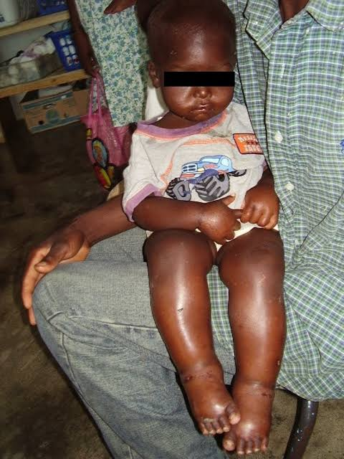

**How is kwashiorkor treated?**

Kwashiorkor can be corrected by eating more protein and more calories overall, especially if treatment is started early.

Give more calories in the form of carbohydrates, sugars, and fats. Once these calories provide energy,give foods with proteins. Foods must be introduced and calories should be increased slowly because you have been without proper nutrition for a long period. Your body may need to adjust to the increased intake.

Recommend long-term vitamin and mineral supplementation to your diet.

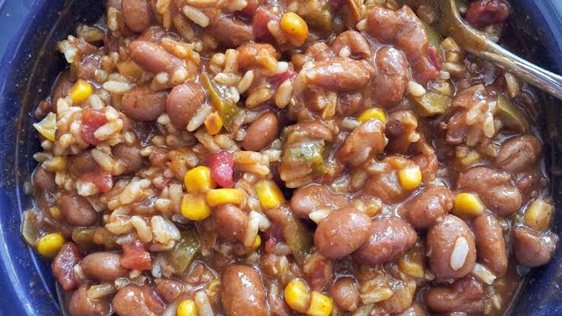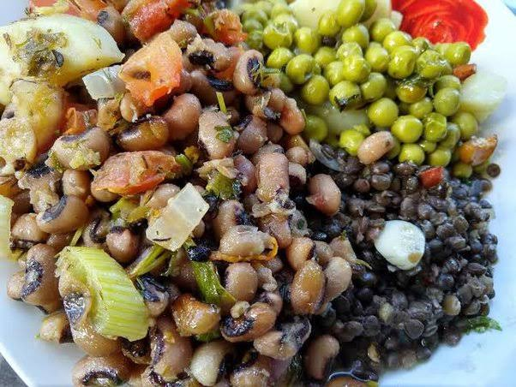

**What are the complications of kwashiorkor?**

Even with treatment, children who have had kwashiorkor may never reach their full growth and height potential. If treatment comes too late, a child may have permanent physical and mental disabilities.

If left untreated, the condition can lead to coma, shock, or death.

**OBESITY**

**What are obesity and overweight**

**Overweight and obesity are defined as abnormal or excessive fat accumulation that may impair health.**

**Body mass index (BMI) is a simple index of weight-for-height that is commonly used to classify overweight and obesity in adults. It is defined as a person's weight in kilograms divided by the square of his height in meters (kg/m2).**

**Adults**

**For adults, WHO defines overweight and obesity as follows:**

**overweight is a BMI greater than or equal to 25; and obesity is a BMI greater than or equal to 30**

**For children, age needs to be considered when defining overweight and obesity.**

**What causes obesity and overweight?**

**The fundamental cause of obesity and overweight is an energy imbalance between calories consumed and calories expended: an increased intake of energy-dense foods that are high in fat and sugars;**

**an increase in physical inactivity due to the increasingly sedentary nature of many forms of work, changing modes of transportation, and increasing urbanization.**

**Changes in dietary and physical activity patterns are often the result of environmental and societal changes associated with development and lack of supportive policies in sectors such as health, agriculture, transport, urban planning, environment, food processing, distribution, marketing, and education.**

**What are common health consequences of overweight and obesity?**

**Raised BMI is a major risk factor for noncommunicable diseases such as:**

* **cardiovascular diseases (mainly heart disease and stroke), which were the leading cause of death.**
* **diabetes;**
* **musculoskeletal disorders (especially osteoarthritis – a highly disabling degenerative disease of the joints);**
* **some cancers (including endometrial, breast, ovarian, prostate, liver, gallbladder, kidney, and colon).**
* **The risk for these noncommunicable diseases increases, with increases in BMI.**

**Childhood obesity is associated with a higher chance of obesity, premature death and disability in adulthood. But in addition to increased future risks, obese children experience breathing difficulties, increased risk of fractures, hypertension, early markers of cardiovascular disease, insulin resistance and psychological effects.**

**BMI Weight status**

**Below 18.5 Underweight**

**18.5-24.9 Normal**

**25.0-29.9 Overweight**

**30.0 and higher Obesity**

**Related images**

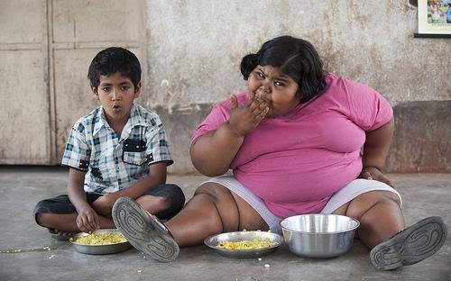

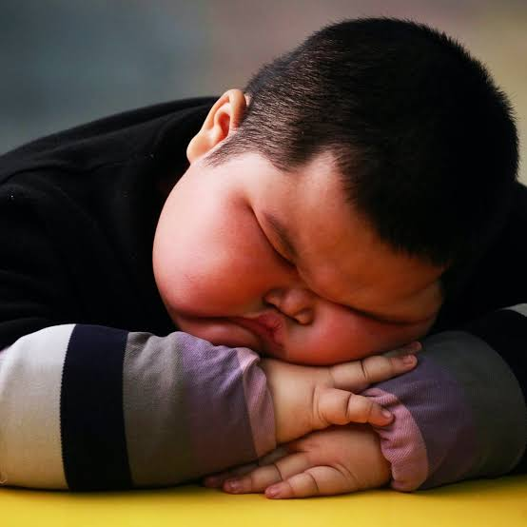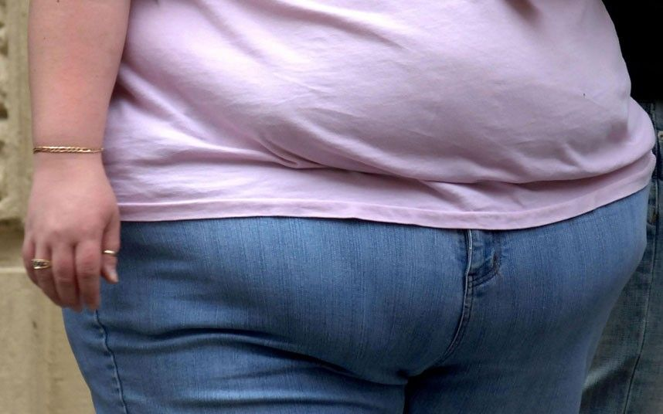

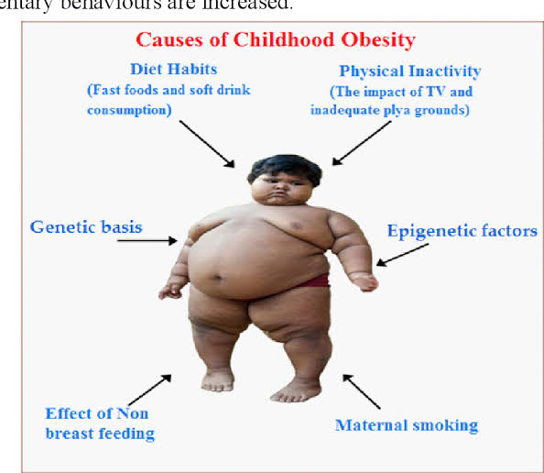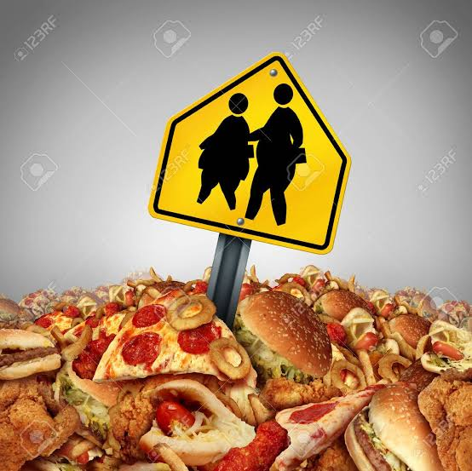

**Treating obesity**

**The best way to treat obesity is to eat a healthy, reduced-calorie diet and exercise regularly.**

**eat a balanced, calorie-controlled diet as recommended by your GP or weight loss management health professional (such as a dietitian)**

**join a local weight loss group**

**take up activities such as fast walking, jogging, swimming or tennis for 150 to 300 minutes (two-and-a-half to five hours) a week**

**eat slowly and avoid situations where you know you could be tempted to overeat**

**THIAMINE (Vitamin B1)deficiency**

**Thiamine, also known as vitamin B1, is one of the eight essential B vitamins.**

**It plays a key role in several important health functions, and not getting enough of it can lead to thiamine deficiency. This deficiency is known as beriberi if it’s severe and chronic.**

**What is thiamine (B1)?**

**Thiamine is a vitamin your body needs for growth, development, and cellular function, as well as converting food into energy.**

**Like the other B vitamins, thiamine is water-soluble. That means that it dissolves in water and isn’t stored in your body, so you need to consume it on a regular basis**

**It plays a key role in several important health functions, and not getting enough of it can lead to thiamine deficiency. This deficiency is known as beriberi if it’s severe and chronic.**

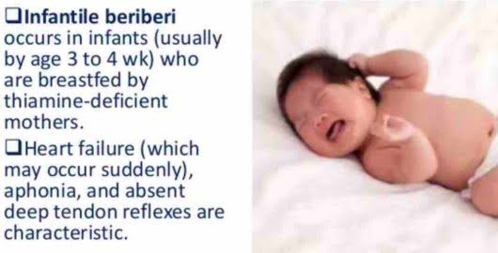

**There are two main forms of beriberi:**

**Wet beriberi, which mainly affects the cardiovascular system, causing poor circulation and fluid buildup in the tissues.**

**Dry beriberi, which primarily affects the nervous system, leading to the degeneration of the nerves. Degeneration typically begins in the legs and arms and may lead to muscle atrophy and loss of reflexes**

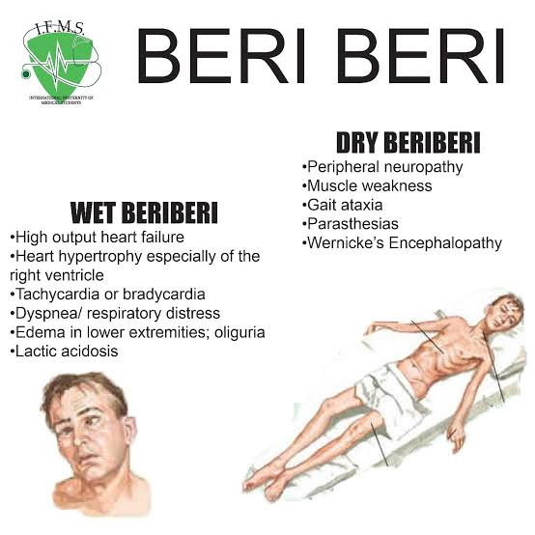

**Fortunately, thiamine is naturally found in a variety of foods and added to others via fortification. It’s also commonly added to multivitamins or taken as an individual supplement or as part of a vitamin B complex.**

**Some of the best places to find thiamine in your diet include foods like:**

* **enriched white rice or egg noodles**
* **fortified breakfast cereal, boiled maize**
* **pork**
* **black beans**
* **sunflower seeds**
* **yogurt**
* **many commercial bread varieties**

**Both blood and urine tests help measure the levels of thiamine in a person’s bloodstream to diagnose beriberi.**

**Treatment**

**The goal of treatment for beriberi is to increase thiamine levels in the body. Doctors may recommend oral supplements or injections to deliver this thiamine, depending on a person’s overall health. They may also suggest taking other supplements to support treatment.**

**During treatment, doctors may also order regular blood tests to check the person’s thiamine levels until they return to normal. A person might need to continue taking thiamine supplements at a lower dosage or make changes to their diet following treatment to ensure that beriberi does not reoccur.**

**RIBOFLAVIN (Vitamin B2) DEFICIENCY**

**Riboflavin, vitamin B2, is a water-soluble and heat-stable vitamin that the body uses to metabolize fats, protein, and carbohydrates into glucose for energy. In addition to boosting energy, riboflavin functions as an antioxidant for the proper function of the immune system, healthy skin, and hair.**

**Riboflavin deficiency can alter iron absorption and cause anemia, which leads to fatigue. Riboflavin is involved in red blood cell production and transportation of oxygen to the cells. Improving the amount of riboflavin in the body can increase circulating hemoglobin levels and increase red cell production. Collagen is a protein found in most skin and hair, so riboflavin is necessary to maintain an adequate collagen level. Taking supplements of riboflavin is also a cure for migraines.**

**Related images**

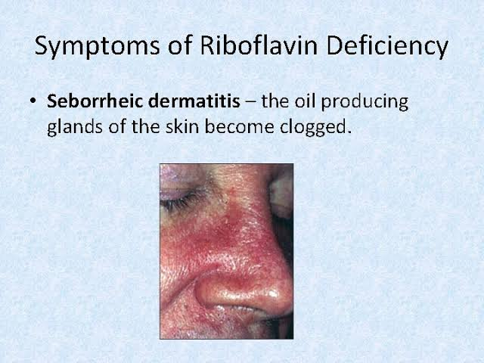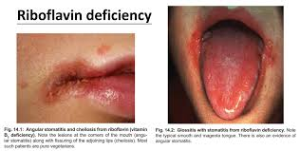

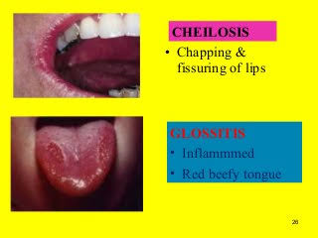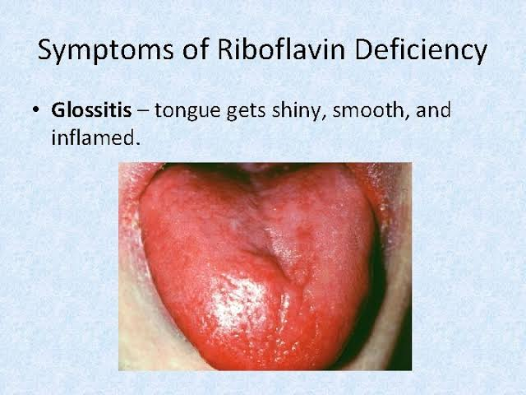Treatment consists of oral or, if needed, intramuscular riboflavin. ). Riboflavin is essentially nontoxic. Dietary sources include milk, cheese, liver, meat, eggs, and enriche

Cereal products

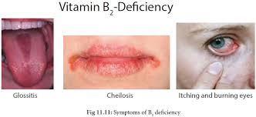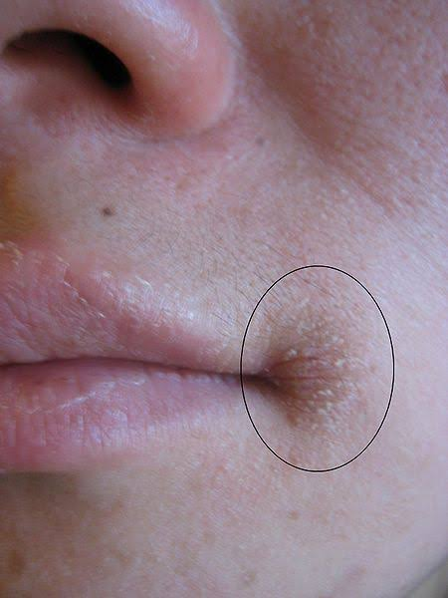

Ascorbic acid (Vitamin C deficiency "scurvy" )

Scurvy is the name for a vitamin C deficiency. It can lead to anemia, debility, exhaustion, spontaneous bleeding, pain in the limbs, and especially the legs, swelling in some parts of the body, and sometimes ulceration of the gums and loss of teeth.

What is scurvy?

Scurvy happens when there is a lack of vitamin C, or ascorbic acid. The deficiency leads to symptoms of weakness, anemia, gum disease, and skin problems.

This is because vitamin C is needed for making collagen, an important component in connective tissues. Connective tissues are essential for structure and support in the body, including the structure of blood vessels.

A lack of vitamin C will also affect the immune system, absorption of iron, metabolism of cholesterol and other functions.

Symptoms

One of the more notable symptoms of scurvy is the loss of and damage to teeth

Vitamin C is a necessary nutrient that helps the body absorb iron and produce collagen.

Symptoms of vitamin C deficiency can start to appear after 8 to 12 weeks. Early signs include a loss of appetite, weight loss, fatigue, irritability, and lethargy.

Within 1 to 3 months, there may be signs of:

anemia,myalgia, or pain, including bone pain,swelling, or edema,petechiae, or small red spots resulting from bleeding under the skin,corkscrew hairs,gum disease and loss of teeth,poor wound healing,shortness of breath,mood changes, and depression

**Related images**

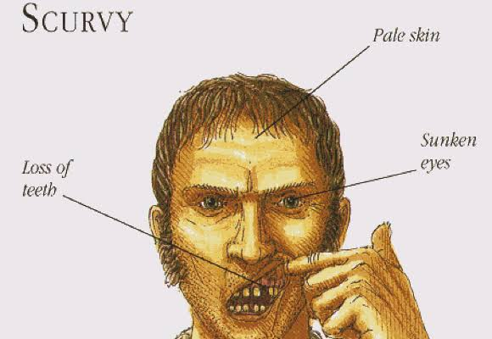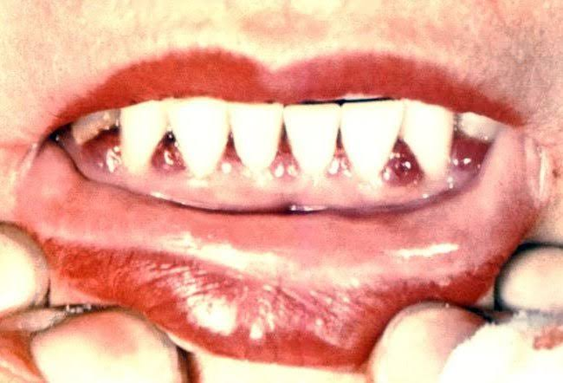

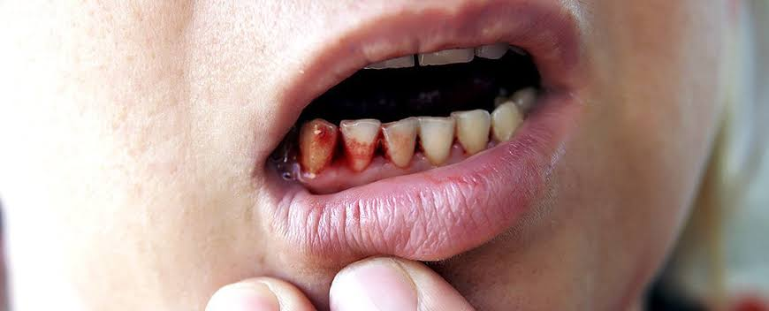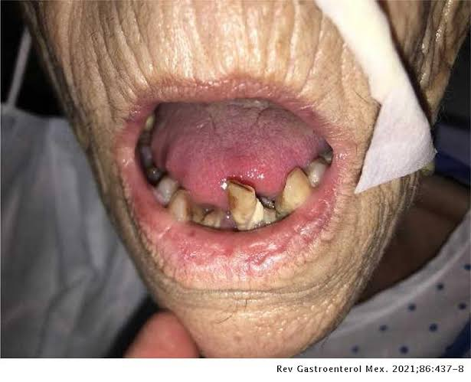

**Sources of Vitamin C good for preventing Scurvy**

**Most fruits**

**Fruits and vegetable Salads**

**Green leafy vegetables**

**Vitamin C suppliments**